A
Project Report On
Shree Sahjanand Vidhyalay

Project Name
School Management

Prepared By:ABHISHEK PANDEY(205119003)

Guided By:DR.R.BALAJI GANESH

-: ACKNOWLEDGEMENT:-
We would like to express our appreciation to the people who have contributed to the successful completion of this PROJECT. I am even so greteful to DR R.BALAJI GANESH for helping me to improve my understanding of numerous concepts in PHP and MYSQL.

We are thankful to respected for giving us opportunity to do this project. Their inspiration and generous support gave us sufficient strength to prepare the projecT.

Last but not least we would like to thank all those who have helped me directly or indirectly in develop in a successful project.

INDEX

- Abstract

- Application Flow

- Data Flow Diagram

- Objective & Scope Of Project

- Definition Of The Problem

- User Requirements

- System Analysis

- Details Of Hardware & Software

- A Complete Analysis & Design Document

- Screen Shots

- Bibliography

-: ABSTRACT:-
We are make this project to help user friendly. In this project the on the School Management. In the this project user can see the details of all about the school details in the web site. Administrator can add the details of the students, staff details, & online addmission details in the web sites.

This project is very useful to the any type of school manage & store the all types details on the web site without any paper work.

Help of this project any one can access the details of the school & if any one stdent want to know about the couses of this school than they are see without visiting the school & without wating the their time. If they are intrasted in the couse than they are registare or the get the fill addmission form on line.

If any one use want to give sugession about the school or the project than user give their details using feedback form.

If any one user want to contect to the administrator or manager of the school or get the details of the contect number & addresses know in the contecct us page & user can contect the administraot using this page.

Application flow

Homepage

About us
Admission
Staff
Standard
Contact us
Feedback
Contact

Standard
Details

Staff details
Stud details
Contact
Details
History
Feedback

DATA FLOW DIAGARAM

LOGIN CHECK
CLIENT

Home Page

End
Admission
Standard
Staff

ADMINISTRATOR

OBJECTIVE & SCOPE OF PROJECT

As students of MCA Field, We try our best to cover all requirements which are used to complete where web application.

We have tried to prepare the project on School Management objects of our project are:

DEFINITION OF THE PROBLEM

System is for the computerized used for the Website . Now a days in area of a computer we see each and every find is being coputerized so, giving autometic and safe way of Admission in an economic and speedly way is a good move for anyWork.

This project is executive developed for any School, can satisfied their customer requirement administrete they give manual ”invoice” gives the date for previous record and the area in which they are given services, any Problem classifies their Principle according to different areas and as city develops day by day new areas added to the cities, this project also provides .

USER REQUIRMENTS

Before designing the system of this software, I search many School information to know their requirements. After that I came to know that what steps are preformed to issue. I have collected many information for record of various details required to make Faculty system.

The analysis of the system specifies the two most basic requirement of staff management.

We can able to update, delete any perticular details of staff with the help of update, delete button. It provides various option to update your record.

In this system, general information regarding staff can be stored separately. This can be used for future reference. In user entry form, details regarding user can be stored .

On the base of the system analysis, the designed of the software is prepared. Every small topic is considered very seriously to fulfill the requirement of the user.

SYSTEM ANALYSIS

Requirements analysies involves the systems entities and attributes. This stage was termimated with the preparation of the list of inputs, outputs and processes for the system commonly known as patient requirement specification. During this stage, I came to know the process involved in transforming the inputs into outputs.

- inputs:
1. Admission entry
2. Staff entry
3. Standard entry
- Outputs:
1. Generate record
2. Recept

SYSTEM ANALYSIS

DETAILS OF HARDWARE & SOFTWARE

- Web Server :- Xampp [5.1.4]
- Web Browser :- Internet Explorer, Morzila
- Tools :- Dream wear 6.0
- Technology :- PHP 4, PHP 5
- Database Server :- My SQL [ 5.0.21]

Software specification:-

- PHP:
PHP is the large no of internet service providers (ISPs) and web hosting companies that support it. Today there are hundreds of thousands of developers using PHP, and it’s not surprising that there are so many, considering that several thet several million sites are reported to have php installed.

PHP is a cross platform technology and that once you’ve wrriten your web page, it’s easy to get it up and running on our web server but how does php compare with other technologies out there? Well, comparing php with perl is a bit tricky becouse they were designed for different things.

PHP was specifically designed to rapidly create dynamic web content; perl was not. As a result, perl can sometimes be a complicated language that can become prohibitive for users who want to create web pages. Comparing php with asp is a more balanced comparison, but then you have to pay for asp, and asp doesn’t work well on a variety of platforms it needs to be used on other proprietary for which you also must pay.

- MYSQL:
MYSQL is a freely available RDBMS. Which fully joined the open source community only recentli, when it was released under the GNU public license(GPL). Even before it want free, you didn’t need a license unless you wanted to make money out of it, or run the server on the windows platform.(the windows version of mysql was shareware). Because you now don’t have to pay a dime to use it, this alone makes mysql a solidcandidate for developing application. If the GPL worries you for any reason, or you need to incorporate mysql into a commercial application, you can still buy a commercially licensed version from the developers at www.mysql.com.

- JAVA SCRIPT:-
Today’s web site needs to go much beyound HTML. There is a definite need to allow user, browsing through web site to actually interact with the web site.

The web must be intelligent enough to accept user input and dynamically structure web page content, tailor made, to a user’s requirements.

Users, who browse throush a web site today, prefer to choose to view what interests them.

Hence even the content of a web page needs to be dynamic based on what a user wishes to see.

This requires a web site development that will allow the creation of interactive web pages.

Capturing user request is traditionally done via a form.

The web site development envirenment should also provide the facility for validafing.

Javascript is an object oriented language thwt allows creation of interactive web pages.

The advantages of javascript:-
- An interpreted language.
- Embedded within HTML.
- Minimal syntax easy to learn.
- Performancesign for simple, small programs.

A COMPLETE ANALYSIS &
DESIGN DOCUMENT



ADMISSION ENTRY TABLE

Fields | Data type | Size | Description
Id | INTEGER | 3 | You can use to generate the id.
Name | VARCHAR | 30 | You can specify the stud name.
Standard | VARCHAR | 10 | Your can specified the standard

STAFF TABLE

Field | Data type | Size | Description
Id | INTEGER | 3 | You can use to only id use
Name | VARCHAR | 25 | You can specified the teacher name.
Designation | VARCHAR | 10 | You can specified the teacher designation.
Qualification | VARCHAR | 15 | Use the teacher qualification
experience | INTEGER | 3 | experience of teacher
contact | VARCHAR | 10 | Teacher of contact no.
email | VARCHAR | 35 | Use of Teacher email.

STANDARD TABLE
Field | Data type | Size | Description
Id | INTEGER | 3 | You can use to only id use
Standard name | VARCHAR | 30 | specified the standard name
Intake | VARCHAR | 4 | They are use to intake place
Fees | INTEGER | 5 | Use to the stud fees

Validation
1. User must be filling up the all fields.
2. User can not enter character value in numeric fields.
3. User can not enter numeric value in character fields.
4. Customer id is a primary key so it can not repeat.
5. Payment process in online.

LIMITATION & FUTURE APPLICATIONOF PROJECT

Limitation:-
Only this User is pay of School Management in under the city category.

Future application:-
All the user are School Management.

Homepage

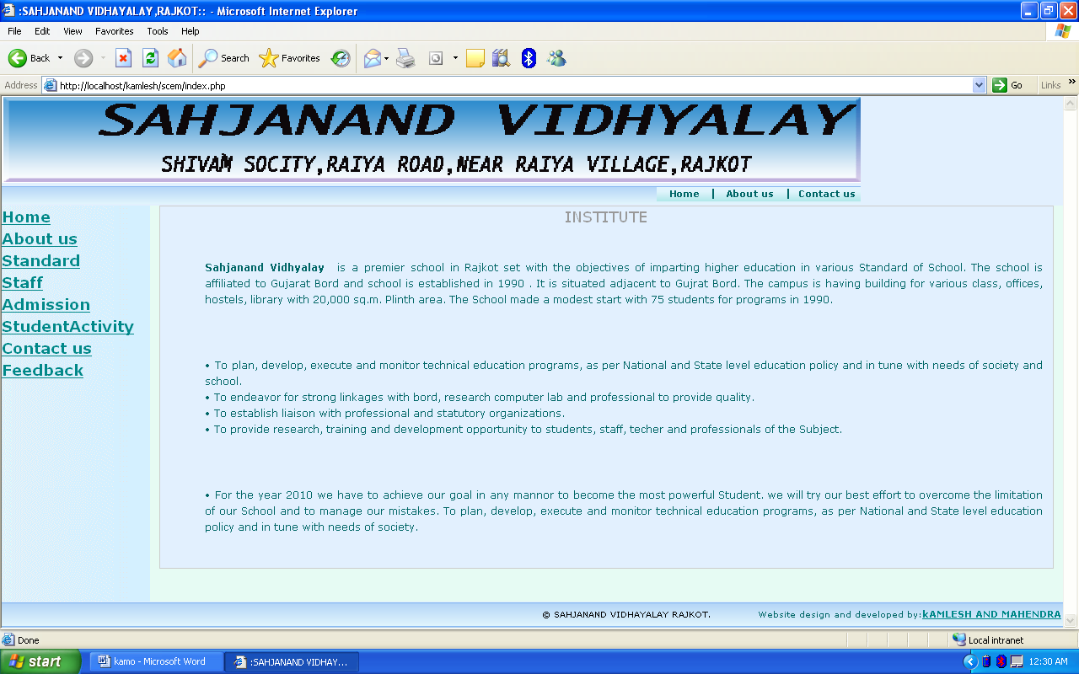

Admission

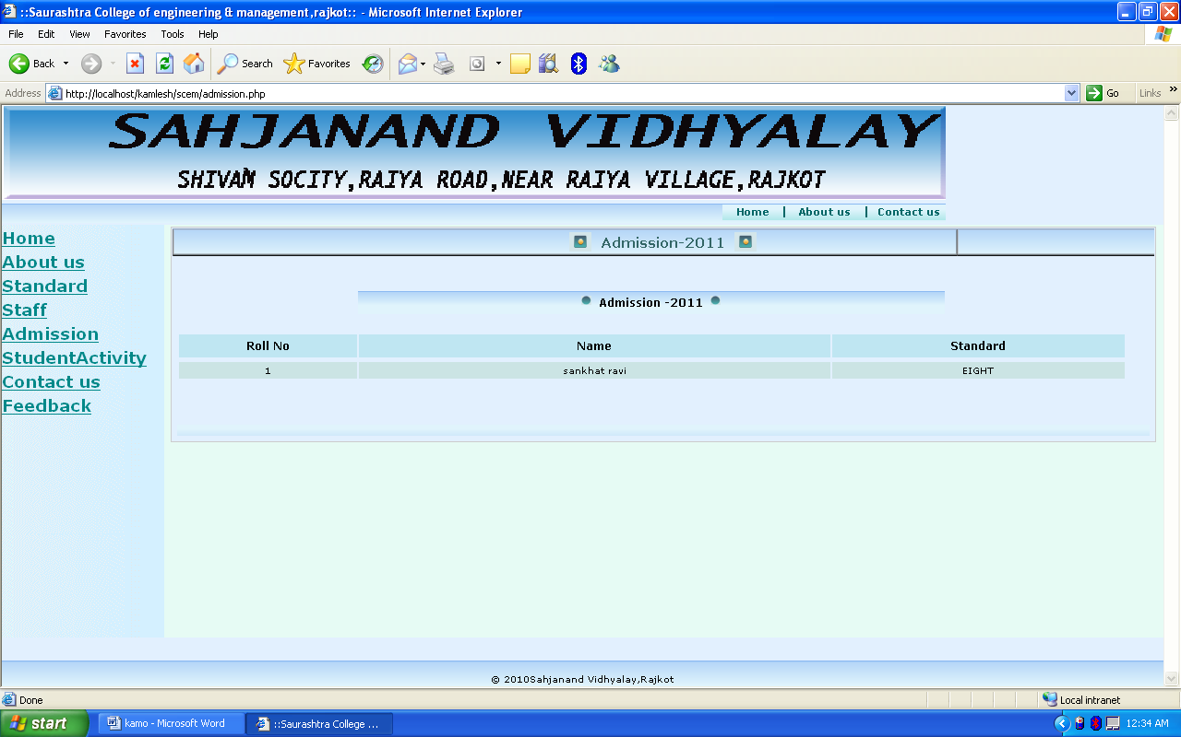

Staff

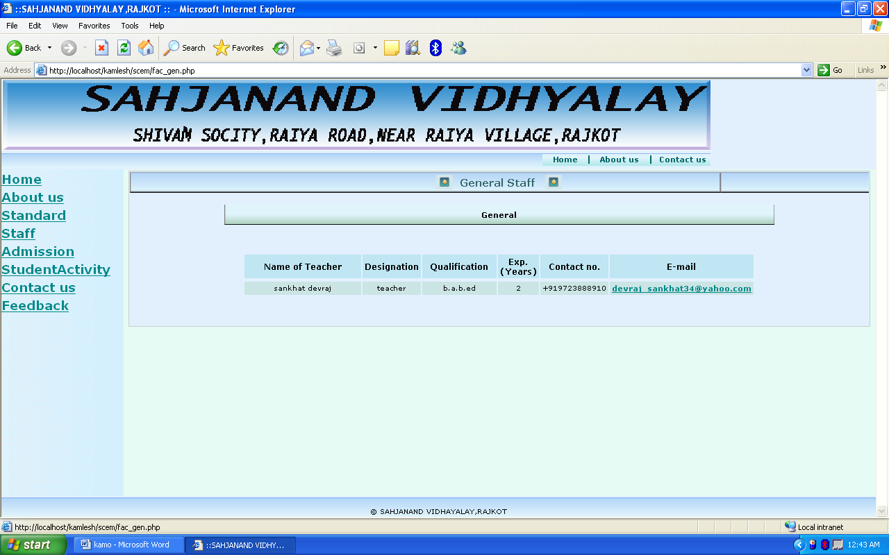

Standard

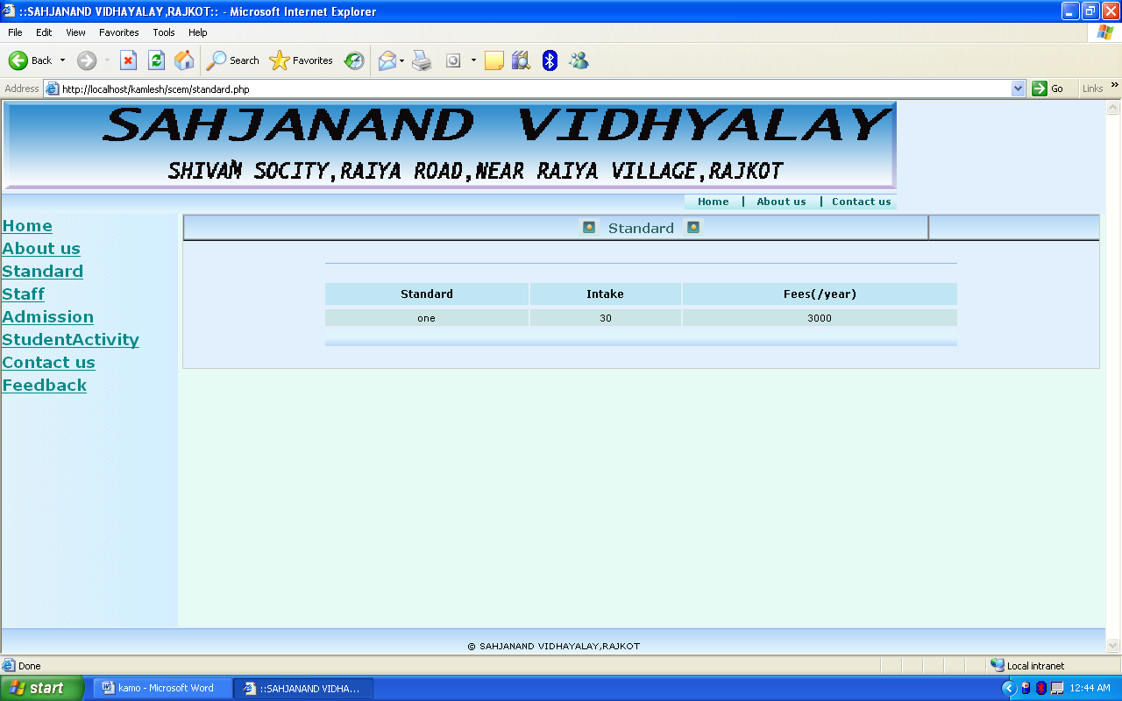

Student Activity

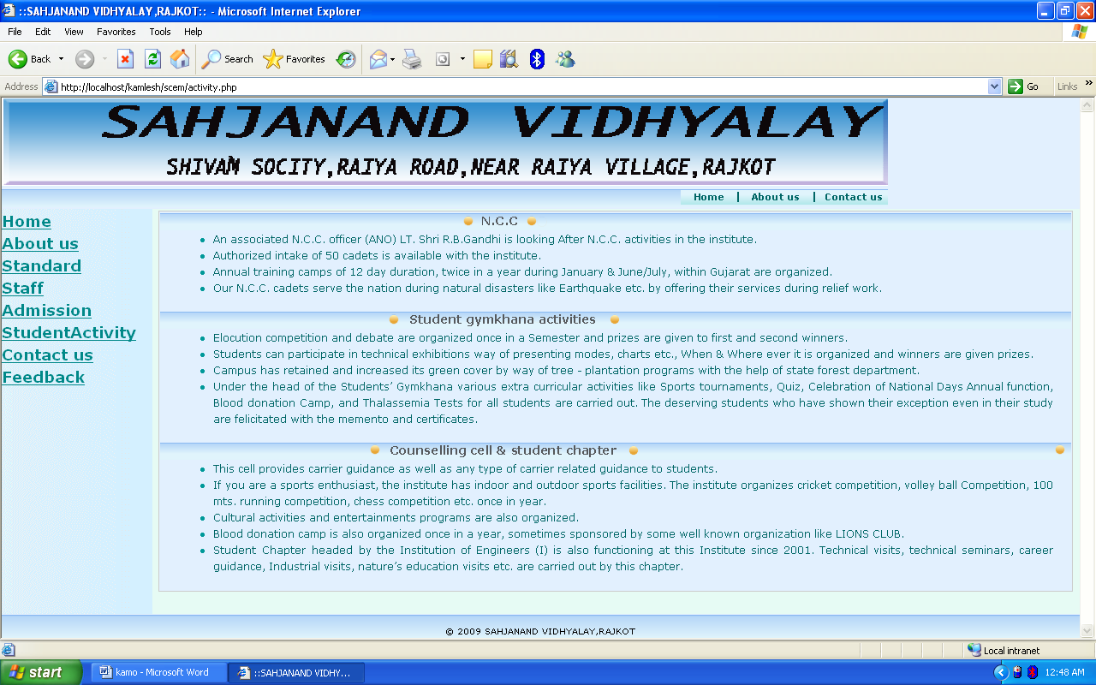

Contact Us

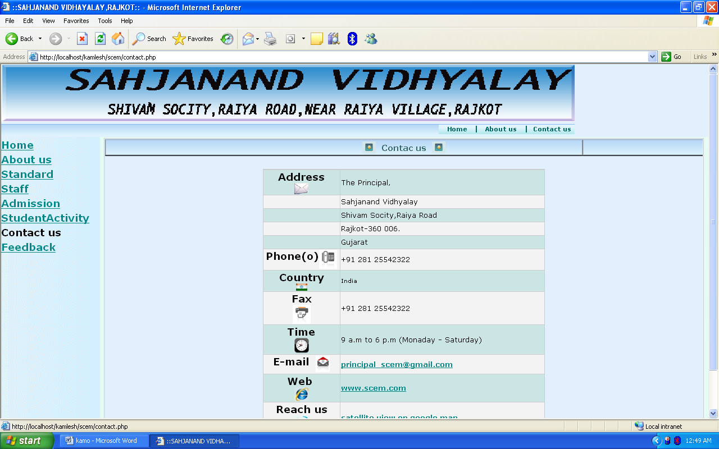

About us

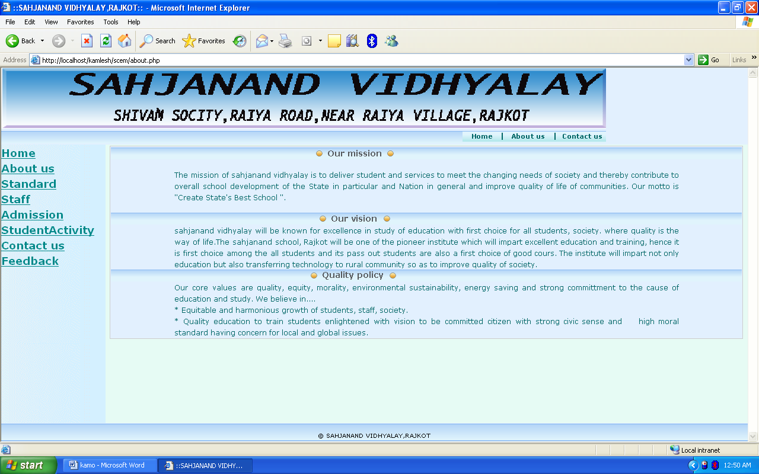

Feedback

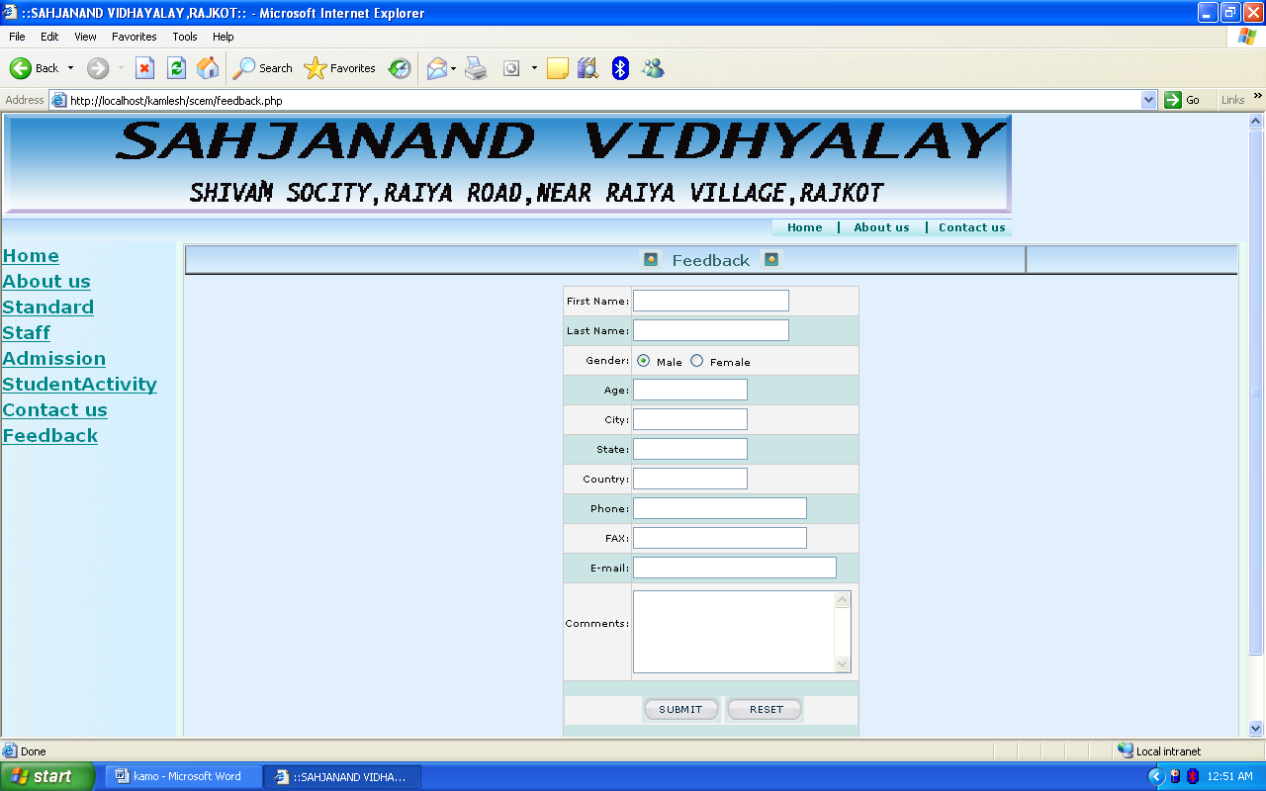

Login Form

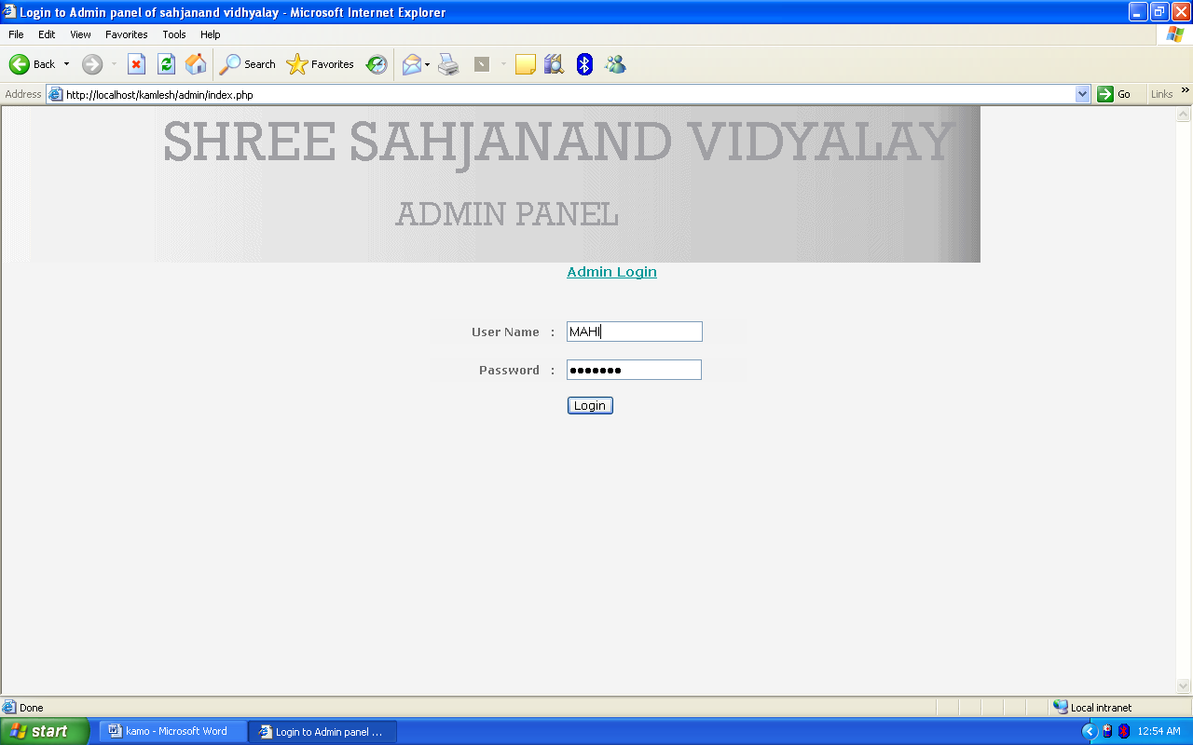

Admission

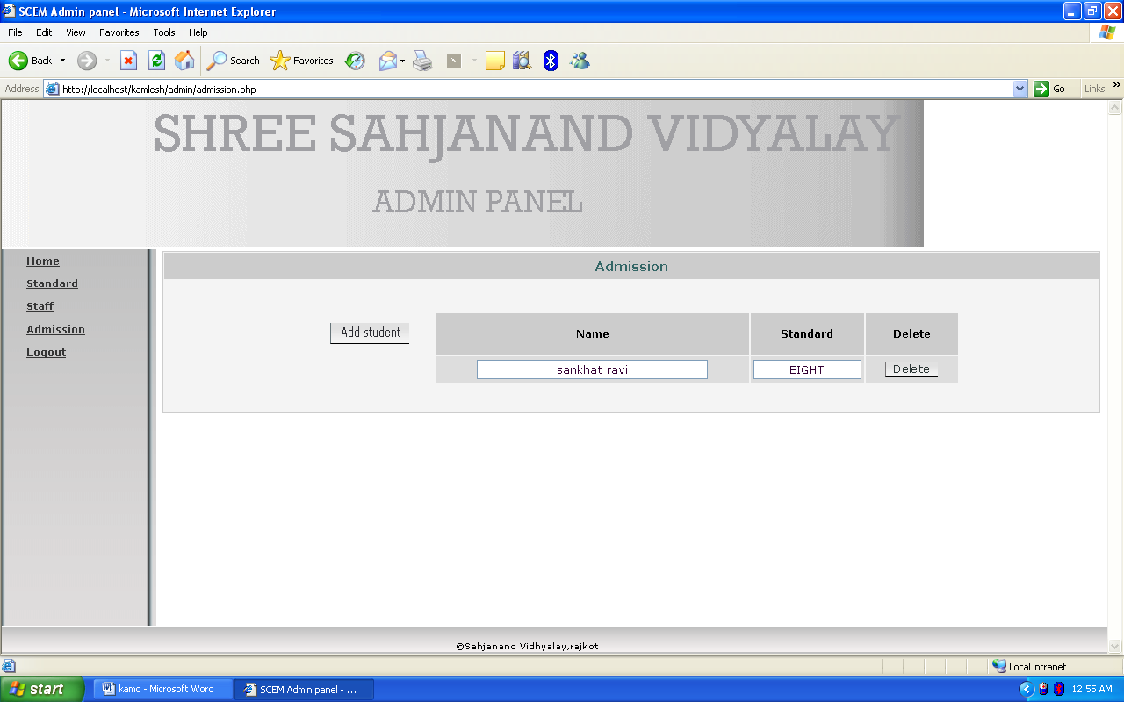

Standard

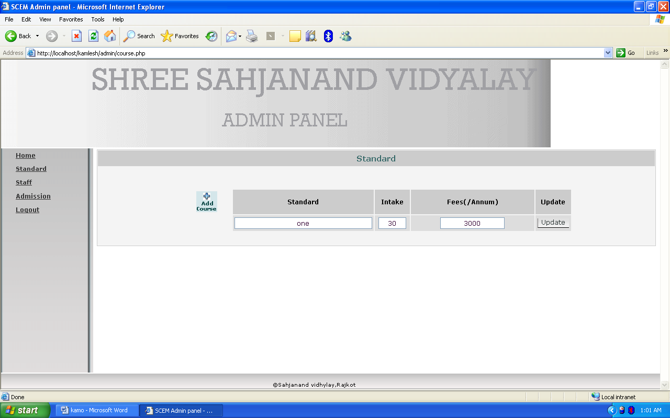

Staff

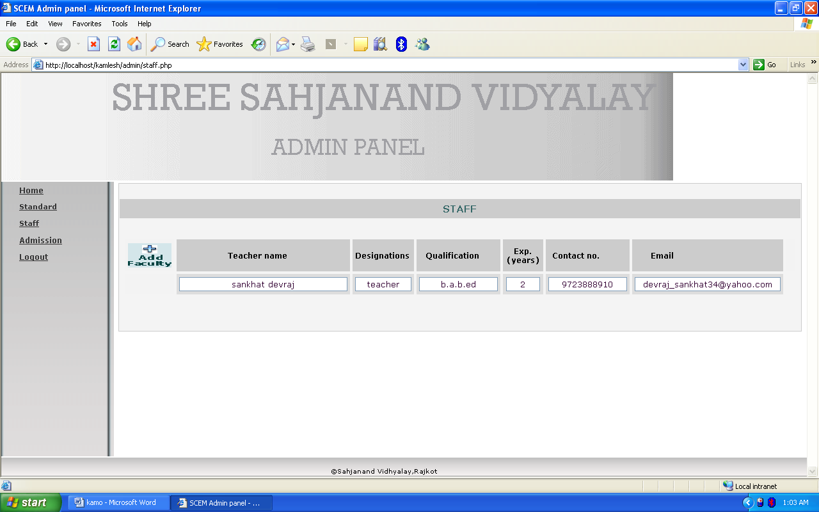
BIBLIOGRAPHY

BOOK NAME : BEGINNING PHP5
AUTHOR : DAVID MERCER
ALLAN KENT
PUBLICATION : WILEY

BOOK NAME : HTML, JAVASCRIPT
AUTHOR : BAYROSS
PUBLICATION : BPB

